Single SSL Certificate for Multiple

Prerequisites:

* Two Windows 2016 machines in same Vnet.

Domain Controller(VM)

Domain Connected Server (VM1)

* One valid DNS from a domain provider (ex: godaddy, freenom)

- Our DNS (ositest.tk)

Steps:

Installing Domain Controller:

* Firstly go to ‘Server manager’

Server manager -> Dashboard -> Add Roles and Features

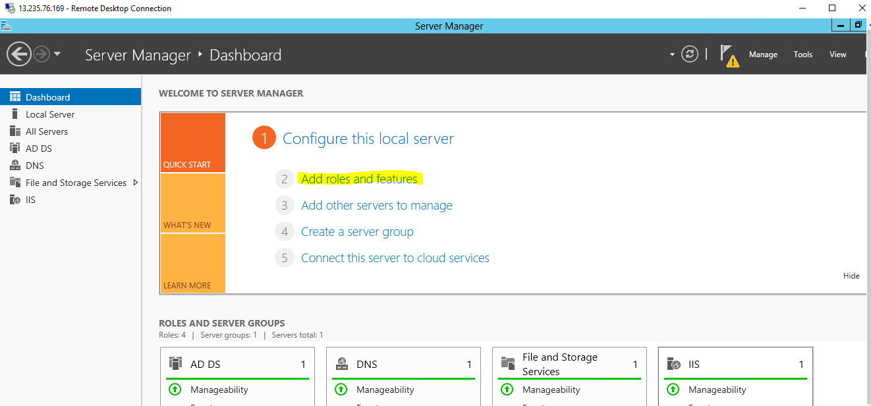

* Click Add roles and features and select installation type as ‘Role-based or feature based installation’
* In server roles install ‘Active Directory Domain services’.

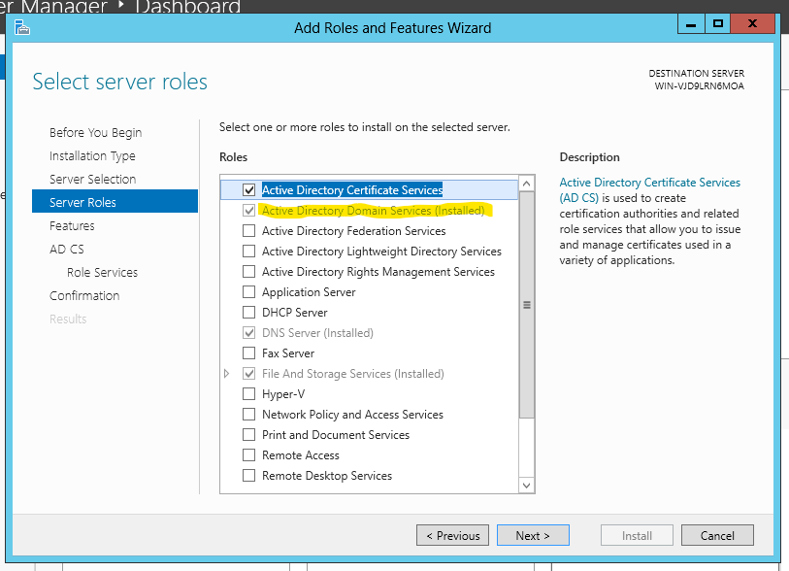

* Click on Next and Checkbox Restart automatically and install.
* After installation restarts the server.
* Go to Notifications and click on promote this server to a domain controller.

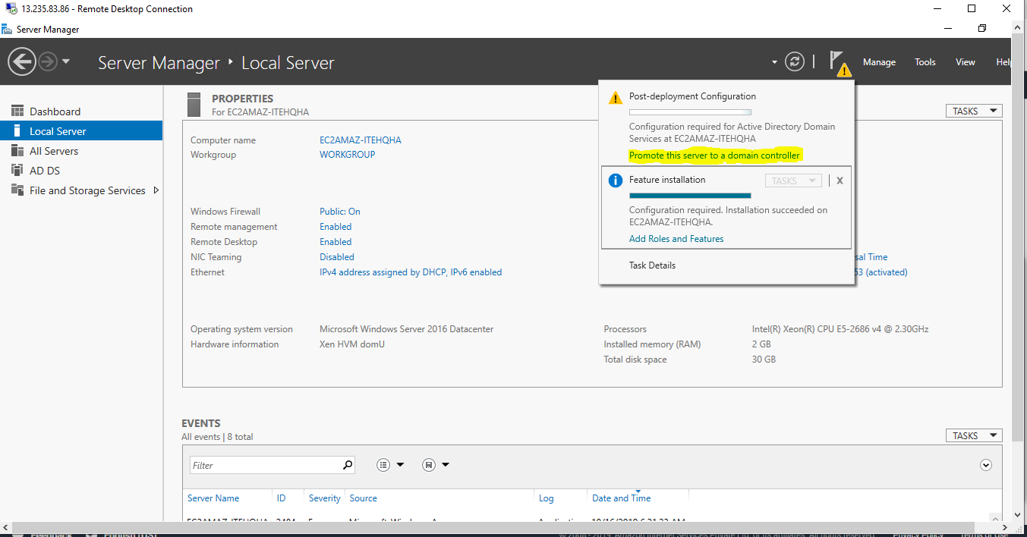

* Now configure the Active Directory Domain Services Configuration wizard

Click on Add a new forest and give the domain (For Example: osi.local)

Click on Next and Install

Go to Local Server and Check for domain as osi.local

* Go to Control Panel -> firewall -> Turn off firewall

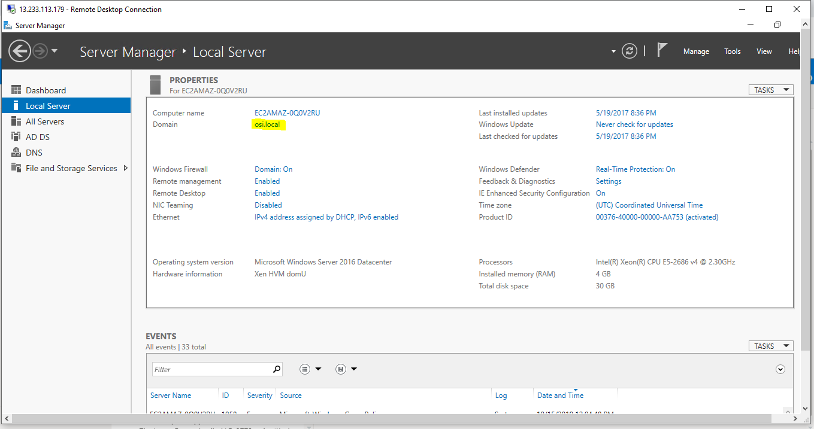

* Create another machine and open Control Panel
* Control panel -> Network and Internet -> Network and Sharing Centre -> Ethernet -> Properties -> Internet Protocol Version 4 -> Properties -> General -> checkbox ‘Use the Following DNS Server addresses’ -> preferred DNS server (give private IP of Domain Controller server) -> click on ok.

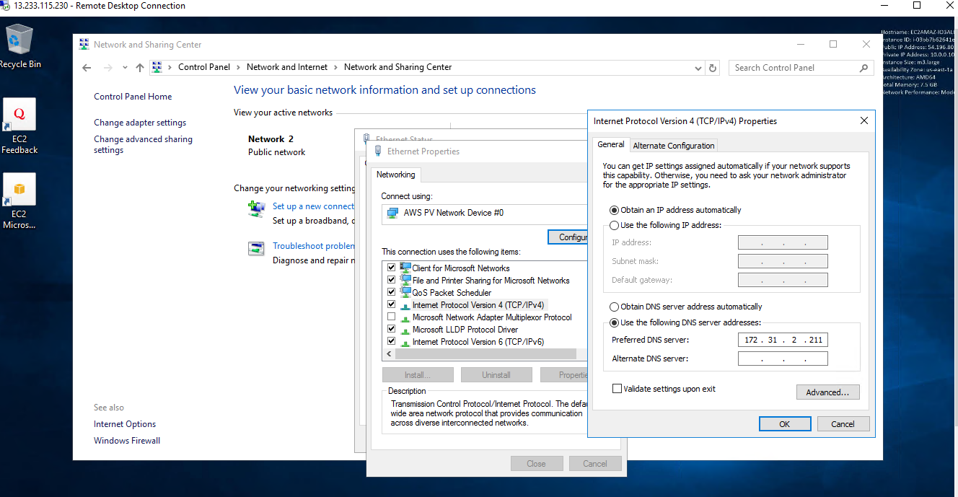

* Go to ServerManager -> click on Domain -> Change workgroup name to vm1 -> give domain as osi.local - > click ok.

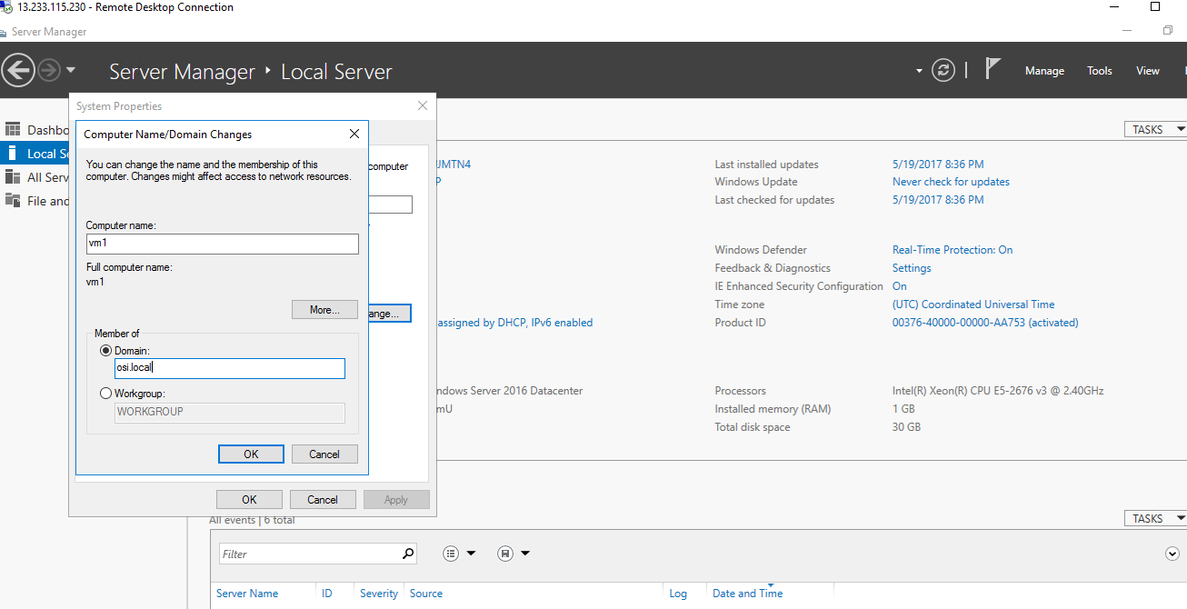

* After clicking on OK connection will be made and it will ask for DomainController server’s UserName and Password.
* Now go to DomainController Server (vm)

Go to Domain Controller Options and create a password.

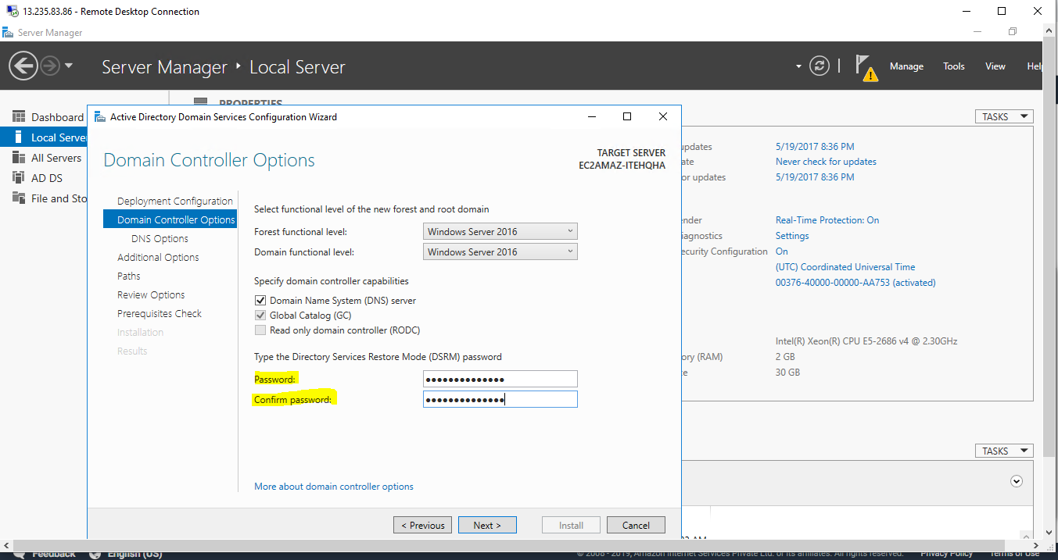

* Servermanger -> Manage -> Click Add roles and features and select installation type as ‘Role-based or feature based installation’ -> Active Directory Certificate Service, Web Server

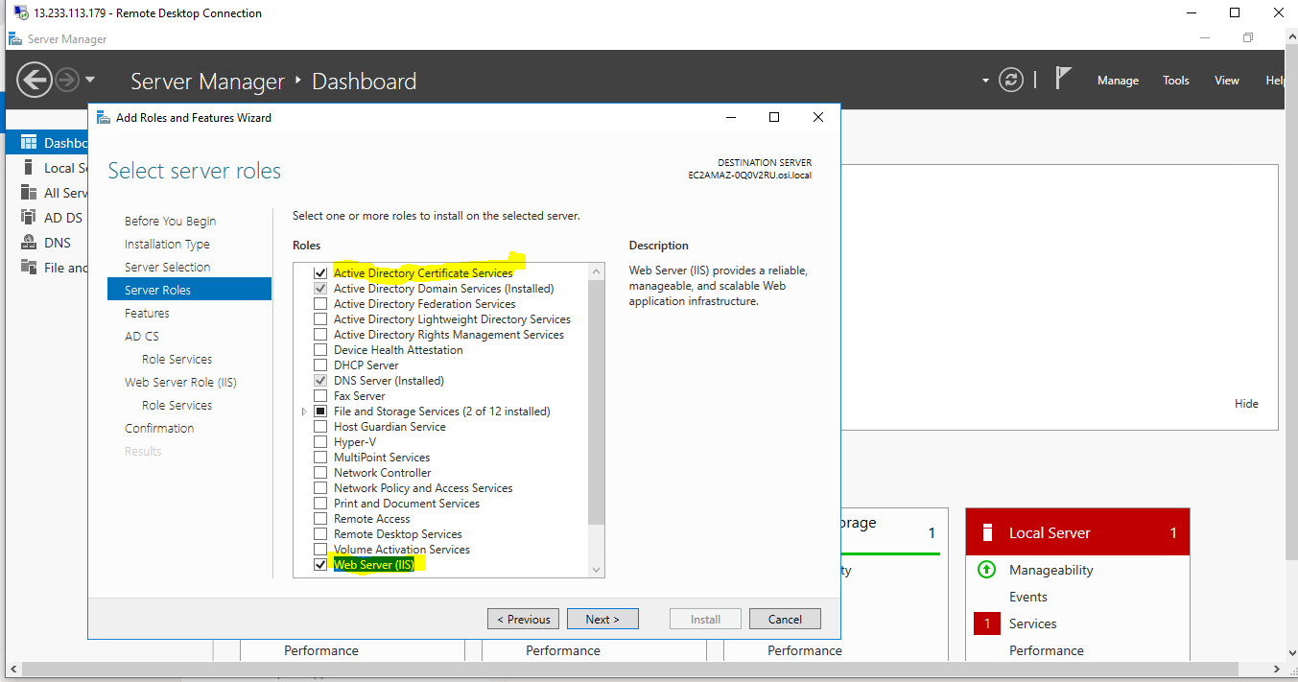

* Click on Next and Checkbox Restart automatically and install.

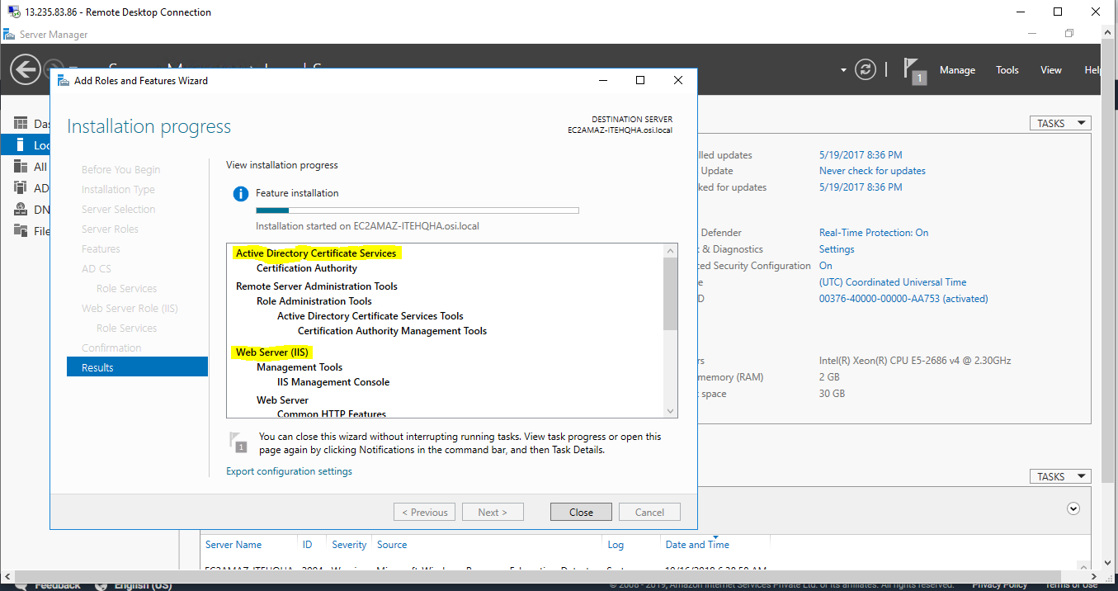

* Now we have to configure Active Directory Certificate service.

Give the credential as OSI/Administrator and click on next.

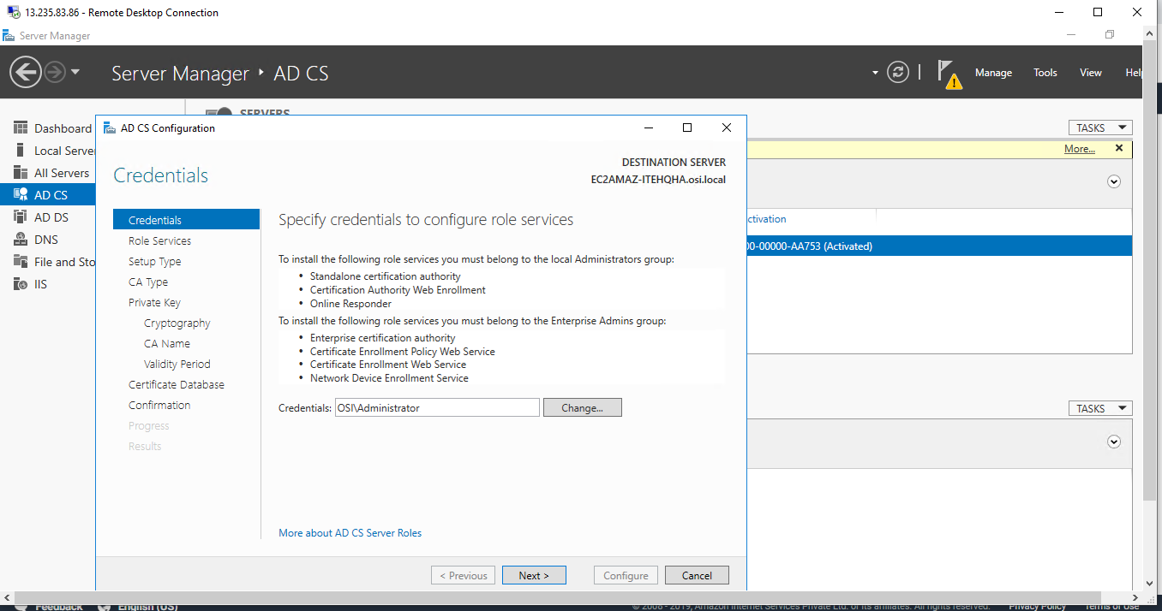

Keep all the default values and configure.

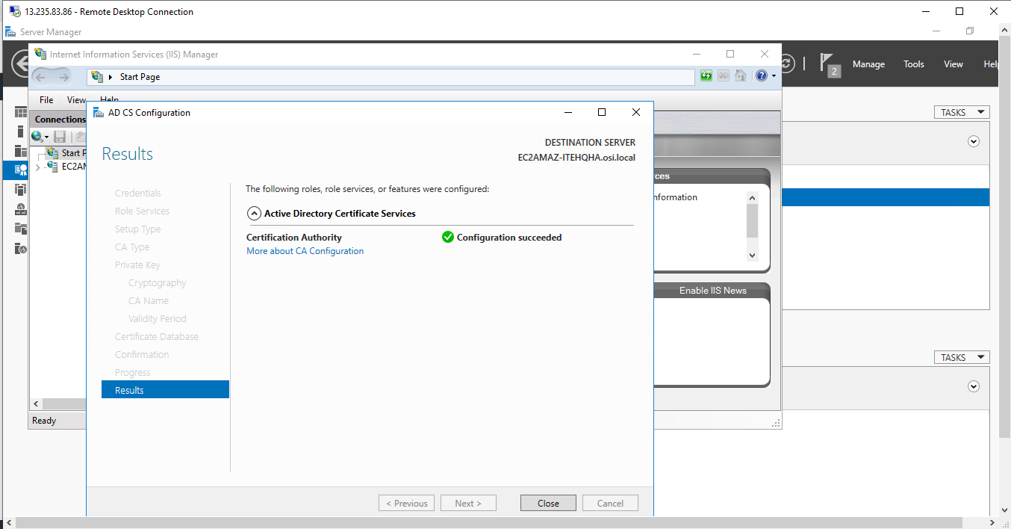

* Now, go to Tools -> Internet Information Services(IIS) Manager

Create Domain Certificate -> give the details of org, state, country -> next

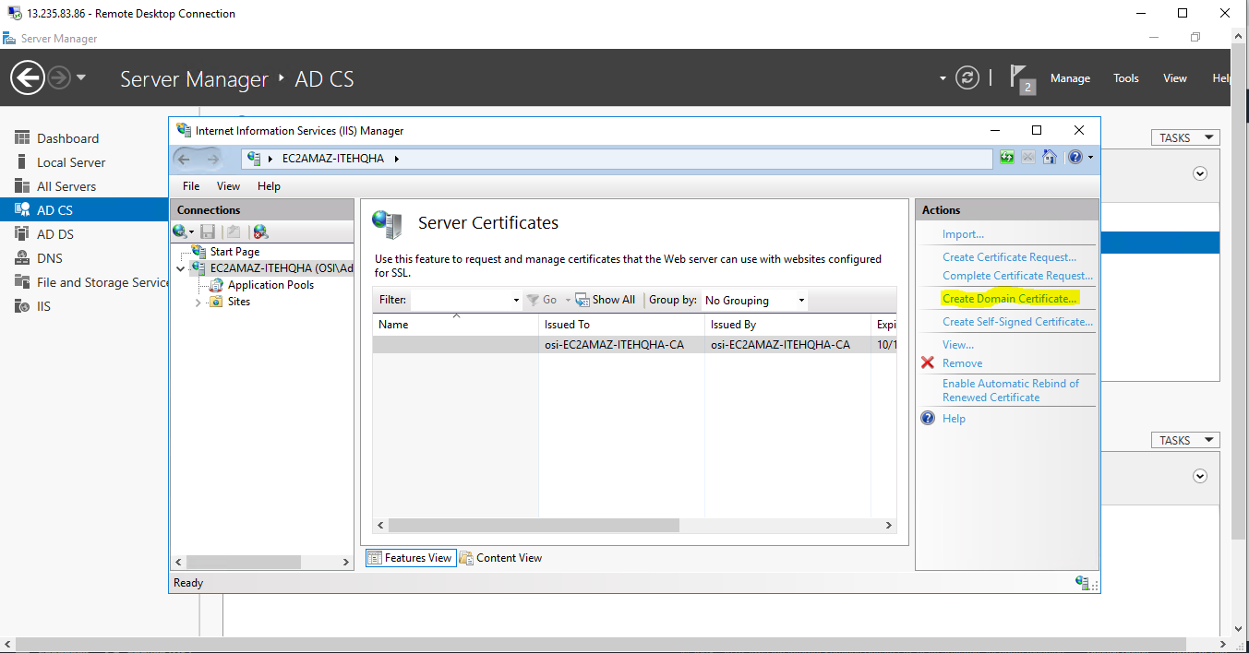

-> select the system name and click finish

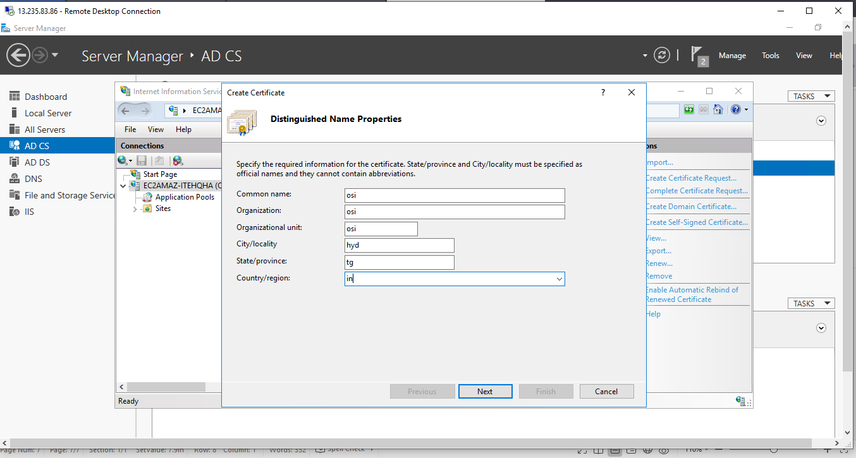

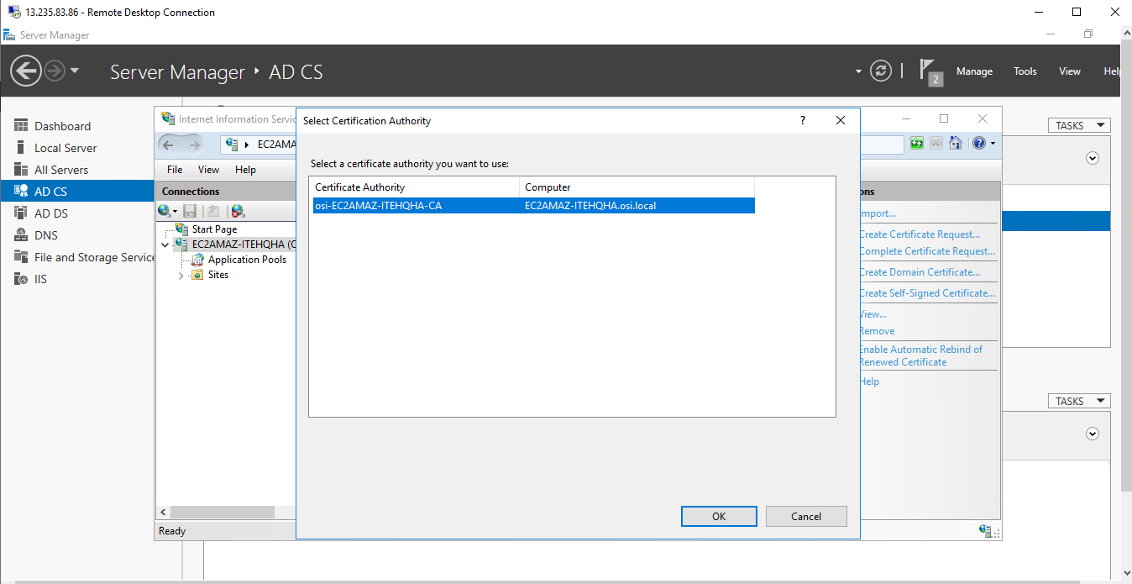

* Check for the certificate by clicking on Computer name -> Server Certificates

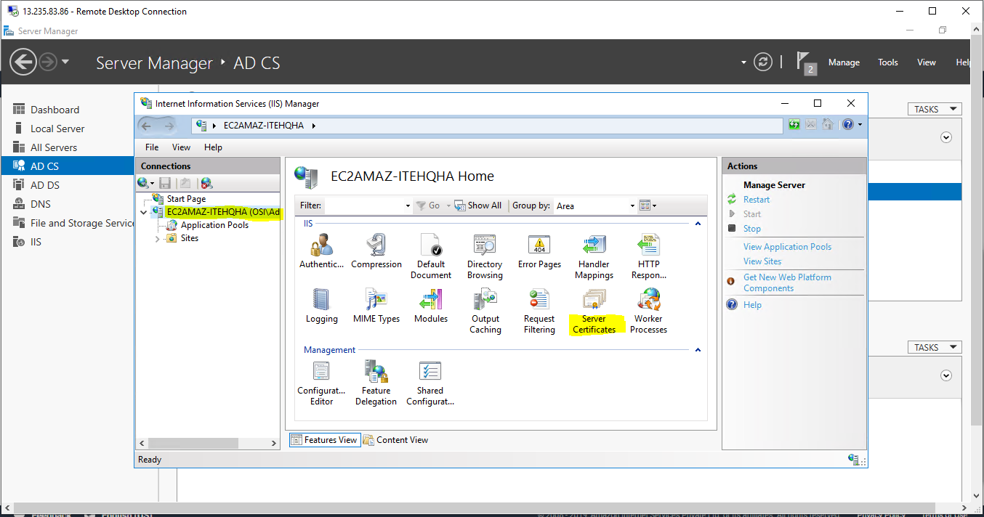

Make sure the certificate exists.

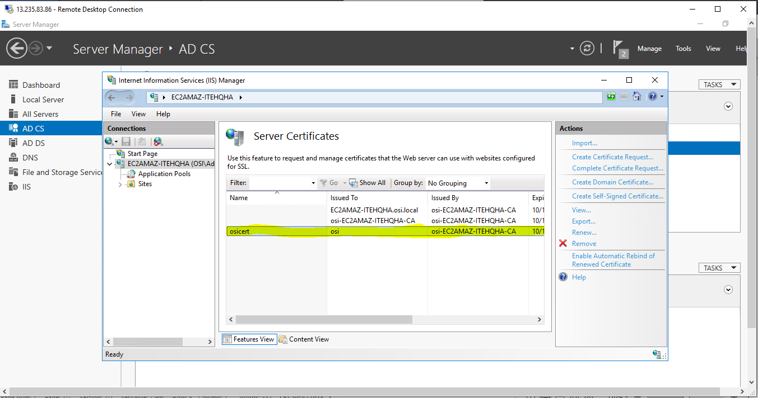

* Go to VM1 machine and server manager -> manage ->webserver( IIS)
* After installing IIS webserver, host a website at server manager -> AD CS -> Sites -> Add Website

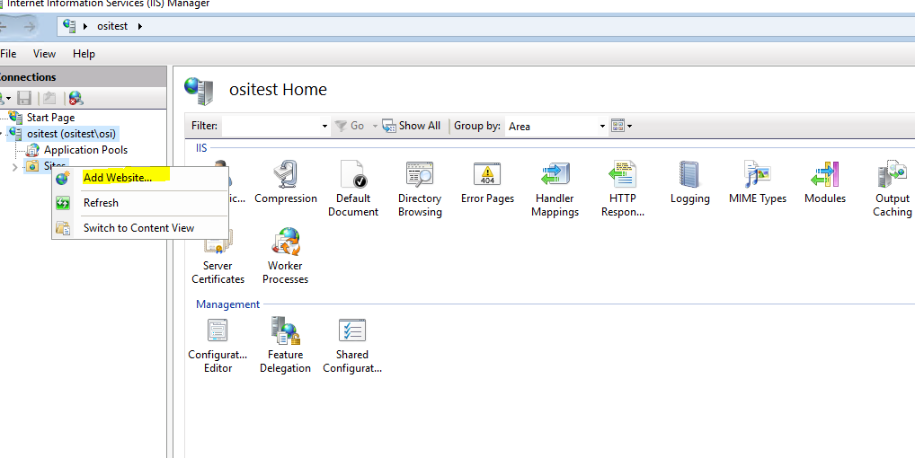

Configure the website by giving website path.

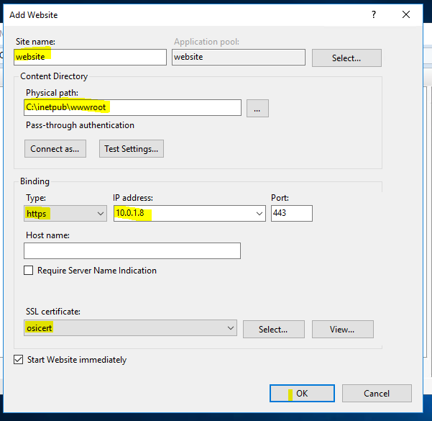

Click OK

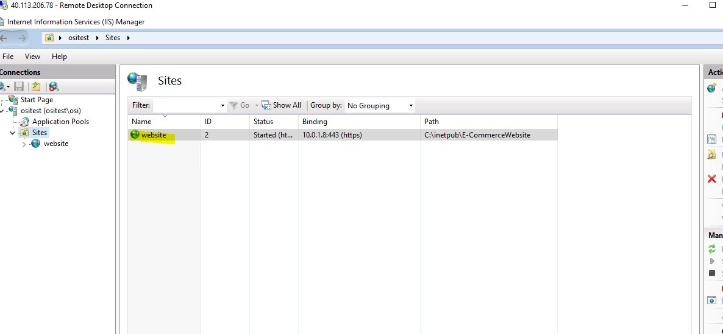

Now the SSL certificate is configured on Domain Controller should apply VM1 machine IIS server.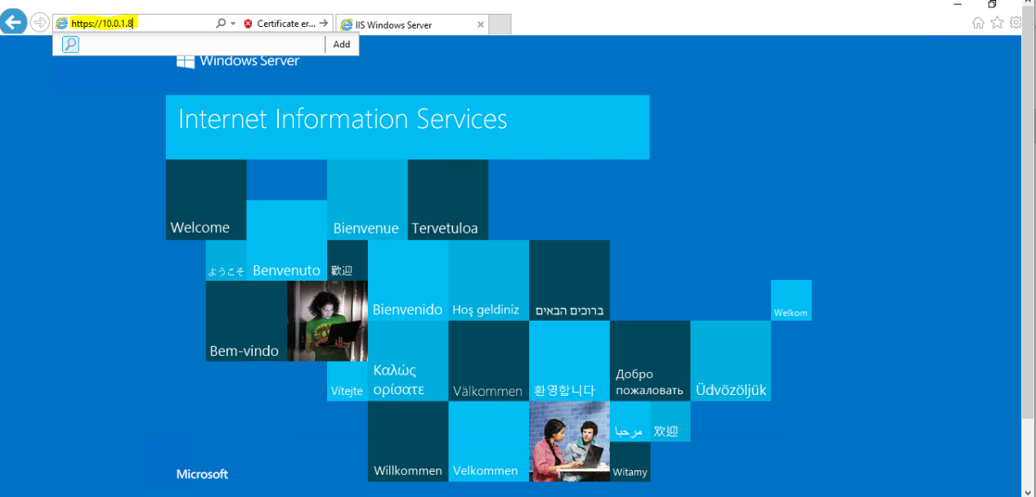

* Take a public DNS and map publicIP of VM1 by adding ‘A’ record to DNS (ex : ositest.tk)

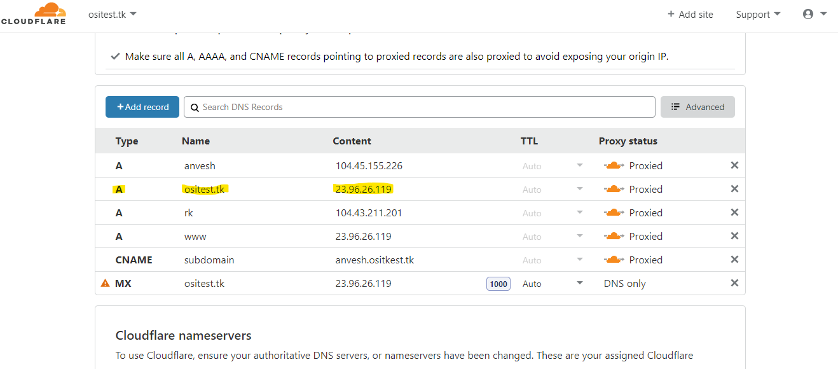

* Now SSL certificate installed on Domain Controller should also apply to the DNS (ex : ositest.tk)

